Competitive Analysis

Introduction

For our Final AVIS 150 project, our team is to create a mobile app concept that solves a problem in a designated market. Our group chose to go with Clothing Retail, and we are creating a retail store called Shur’nuf.

Shur’nuf is best described as retail shop that sells vintage, retro, kitschy products and boasts an urban-hip vibe.

Criteria Outline

We concluded that our three direct competitors are:

UrbanOutfitters:

Urban Outfitters, Inc. is a publicly traded American company that owns and operates over 4000 retail locations across five retail brands: Urban Outfitters, Anthropologie, Free People, and Terrain.

**Considerations:**

* Business Size: Global
* Product Offering
* Direct Audience: 13-35 Crowd
* Monetize through in-app purchases

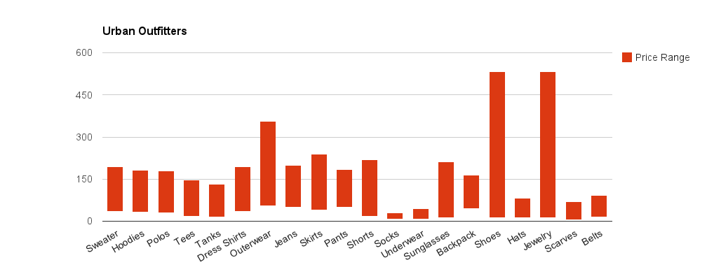

Zumiez:

Zumiez is a based, specialty apparel store founded by Tom Campion and Haakenson in 1978, and publicly traded since 2005. "Offering gear and clothing for the skater, snowboarder, and surfer," Zumiez sells action-sports related clothing and has created an image based around action sports like skateboarding, snowboarding, and motocross.

**Considerations:**

* Business Size: Global
* Product Offering
* Direct Audience: 13-35 Crowd

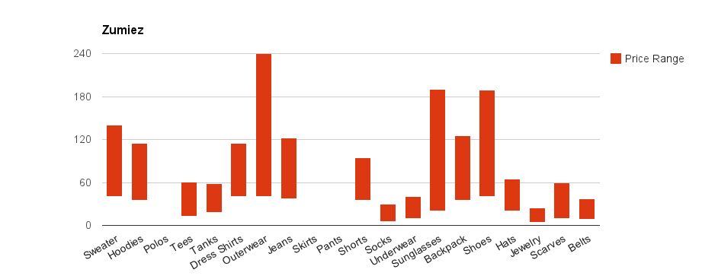

West 49:

West 49 Inc., is a Canadian specialty retailer of fashion and apparel, footwear, accessories and equipment related to the youth action sports lifestyle. C.E.O. Sam Baio established West 49 in 1995. The retailer operates more than 130 stores across the country.

**Considerations:**

* Business Size: Global
* Product Offering
* Direct Audience: 13-35 Crowd

